Session 14 -1

import java.util.Arrays;

class Solution {
public String largestNumber(int[] nums) {
// Convert the integer array to a String array
String[] asStrs = new String[nums.length];
for (int i = 0; i < nums.length; i++) {
asStrs[i] = String.valueOf(nums[i]);
}

// Sort strings using a custom comparator
// If (B + A) is lexicographically greater than (A + B), swap them
Arrays.sort(asStrs, (a, b) -> (b + a).compareTo(a + b));

// If the largest number after sorting is "0", the entire number is 0
if (asStrs[0].equals("0")) {
return "0";
}

// Build the final large number string
StringBuilder largestNumberStr = new StringBuilder();
for (String numAsStr : asStrs) {
largestNumberStr.append(numAsStr);
}

return largestNumberStr.toString();
}
}

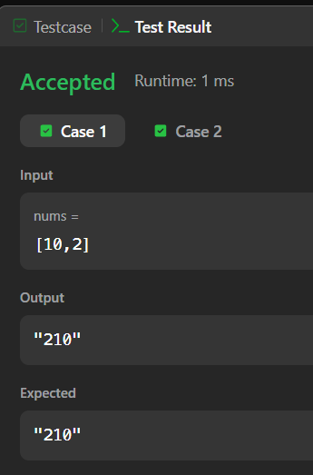

Session 14 - 2
import java.util.*;
class Player {
String name;
int score;
Player(String name, int score) {
this.name = name;
this.score = score;
}
}
class Checker implements Comparator<Player> {
@Override
public int compare(Player a, Player b) {
// Sort by score in descending order
if (a.score != b.score) {
return b.score - a.score;
}
// If scores are equal, sort by name alphabetically
return a.name.compareTo(b.name);
}
}
public class Main {
public static void main(String[] args) {
Scanner sc = new Scanner(System.in);
int n = sc.nextInt();
Player[] players = new Player[n];
for (int i = 0; i < n; i++) {
String name = sc.next();
int score = sc.nextInt();
players[i] = new Player(name, score);
}
Arrays.sort(players, new Checker());
for (Player player : players) {
System.out.println(player.name + " " + player.score);
}
sc.close();
}
}

